CJI3 Trace via SE16N Tables (SAP ECC)
Nov 9, 2026 · @Harsh

Overview
CJI3 reads CO line items from COEP, keyed by the WBS object number from PRPS. To trace a WBS fully you follow two paths: COEP to COBK to the FI documents, and COBRB to the asset tables.
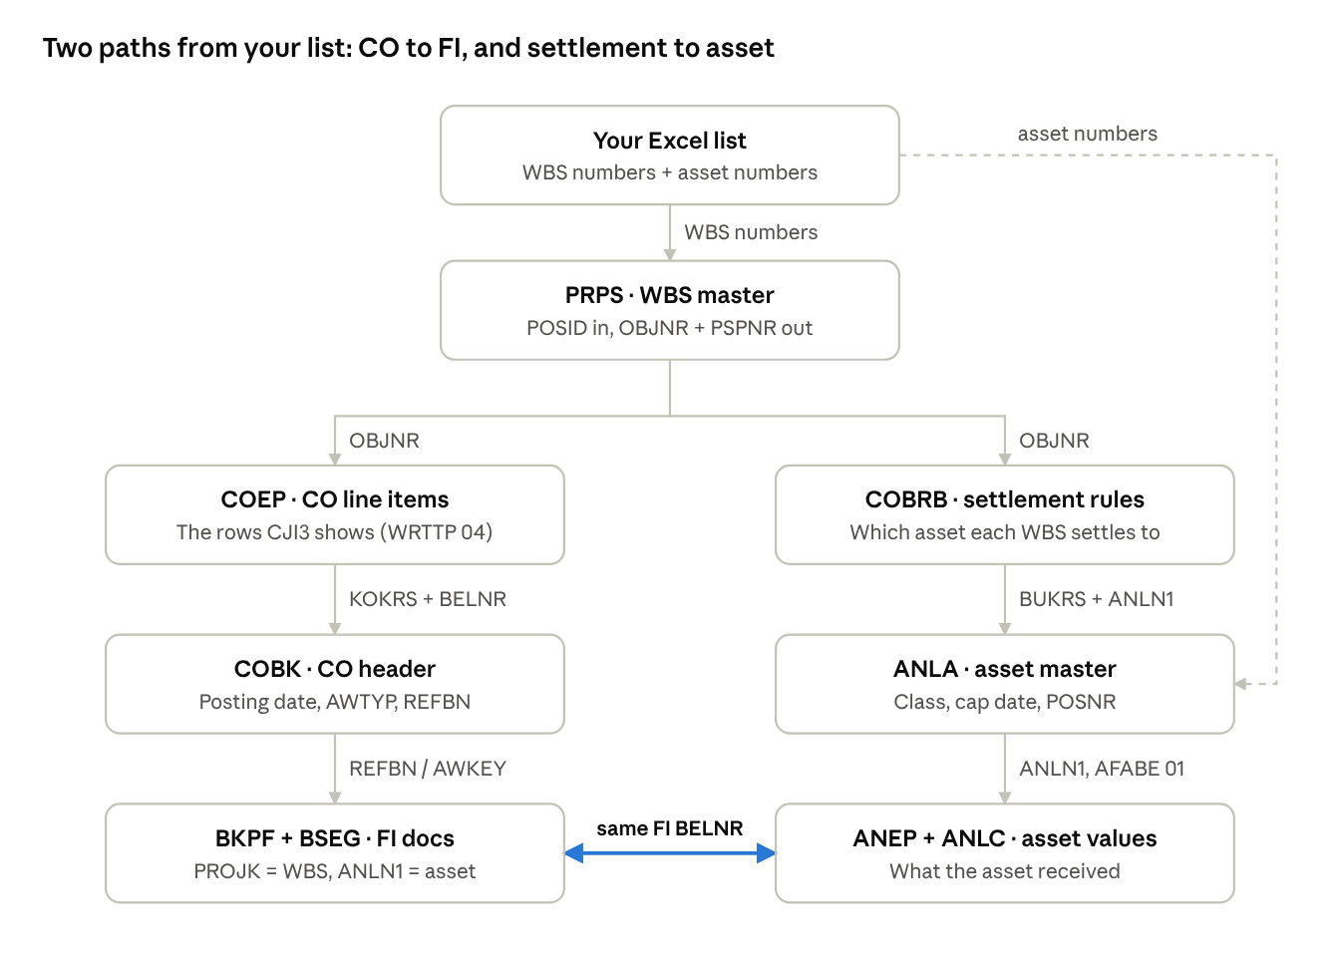
SE16N table trail · WBS to FI and to asset
The left path rebuilds CJI3 and finds the FI document behind each line. The right path shows which asset each WBS settles to. The highlighted link is the proof: the settlement FI document number in BSEG matches the one in ANEP.
Order of work: PRPS first for the whole list, then COEP, COBK, BKPF and BSEG, then COBRB, ANLA and ANEP. SQVI Query 1 and Query 2 below collapse most of this into two runs.

Worked example
Every step below traces this one Excel row end to end. Values are illustrative; your WBS format and number ranges will differ.
Excel column | Example value
WBS element | P-1025-01-03
WBS description | Store 1025 refrigeration upgrade
Asset under construction (AuC) | 4000012345-0
Final asset | 1000045678-0
Company code | 1000
Controlling area | 1000
Fiscal year | 2026
What happened on this WBS in 2026:
- June: vendor invoice for refrigeration units, $120,000, posted through MIRO
- July: internal project labour charged, $8,500, a CO-only activity allocation with no FI document
- July: month-end settlement moved $128,500 from the WBS to the AuC
- September: the AuC was capitalized to the final asset
The goal: rebuild CJI3 for this WBS from tables, then prove the $128,500 landed on the final asset.

Step 1: PRPS, convert the WBS
PRPS turns your Excel WBS number into OBJNR, the key every CO table uses. Do this first for the whole list.
In SE16N
- Table: PRPS
- Field POSID: click the multiple selection arrow, then Upload from Clipboard after copying your Excel WBS column
- Leave "Maximum No. of Hits" blank
- Execute (F8)
Example output
POSID | POST1 | PSPNR | OBJNR | PBUKR | PKOKR | PSPHI
P-1025-01-03 | Store 1025 refrigeration upgrade | 00048213 | PR00048213 | 1000 | 1000 | P-1025
What each field gives you
- OBJNR = PR + 8-digit internal number. You paste this into COEP, COBRB and COSP
- PSPNR = internal WBS number. BSEG stores it as PROJK, ANLA as POSNR
- PBUKR / PKOKR = company code and controlling area, needed as filters later
- PSPHI = the parent project. Look it up in PROJ if you need the project definition
Gotcha: SE16N runs a conversion exit, so PSPNR and PSPHI often display as P-1025-01-03 instead of 00048213. That is normal. Trust OBJNR, it is plain text and never converted.
Export to Excel and keep this as your lookup sheet (call it PRPS).

Step 2: COEP and COBK, the CJI3 line items
COEP holds the exact rows CJI3 shows; COBK adds the posting date and the link to FI. Use COVP (a view of both together) if your user can open it, otherwise run COEP then COBK.
COEP (or COVP) in SE16N
Field | Enter | Why
KOKRS | 1000 | Controlling area, keeps the query fast
OBJNR | PR00048213 (paste the full list) | Your WBS from Step 1
WRTTP | 04 | Actuals only. This is what CJI3 shows
LEDNR | 00 | Standard CO ledger
GJAHR | 2026 | Fiscal year
PERIO | 001 to 012 | Periods, 3 digits
Example COEP output
BELNR | BUZEI | PERIO | KSTAR | VRGNG | WKGBTR | SGTXT
200045671 | 1 | 006 | 615000 | RMRP | 120,000.00 | Refrigeration units
200045902 | 2 | 007 | 943000 | RKL | 8,500.00 | Project labour
200046110 | 1 | 007 | 990000 | KOAO | -128,500.00 | Settlement to AuC
Reading it
- VRGNG tells you the source. RMRP = MIRO invoice, COIN = direct FI posting, RKL = activity allocation, KOAO = settlement
- WKGBTR = amount in controlling area currency. MBGBTR = quantity
- KSTAR = cost element. Settlement cost elements (here 990000) offset the gross cost
- Gross cost = 128,500. After settlement the WBS nets to 0, which means fully settled
COBK in SE16N
Paste the BELNR values from COEP, same KOKRS.
BELNR | BUDAT | AWTYP | REFBN | AWORG | USNAM
200045671 | 2026-06-18 | RMRP | 5105600123 | 2026 | JSMITH
200045902 | 2026-07-31 | COBK | 200045902 |  | BATCHUSR
200046110 | 2026-07-31 | AUAK | 0000088812 |  | BATCHUSR
AWTYP decides where Step 3 goes next. COBK means the posting lives only in CO, so there is no FI document to find.

Step 3: BKPF and BSEG, the FI documents
COBK-REFBN points to the FI document, but how you search BKPF depends on AWTYP. Getting this wrong is the most common reason a CO line "has no FI doc".
COBK-AWTYP | Source | How to find it in BKPF
BKPF | Direct FI posting (FB50, FB60) | BELNR = REFBN, plus BUKRS and GJAHR
RMRP | MIRO invoice | AWKEY = REFBN + AWORG, for example 51056001232026
MKPF | Goods receipt | AWKEY = REFBN + AWORG
AUAK | Settlement | AWKEY starts with REFBN, search 0000088812*
COBK | CO-only (labour, allocations) | No FI document exists. Stop here
BKPF in SE16N
- Fill BUKRS = 1000 and GJAHR = 2026 (always, AWKEY alone is slow)
- Paste into BELNR or AWKEY per the table above
- Note the FI BELNR
BKPF-BELNR | AWTYP | AWKEY | BLART | BUDAT
5100003321 | RMRP | 51056001232026 | RE | 2026-06-18
0100023456 | AUAK | 0000088812 | SA | 2026-07-31
BSEG in SE16N
Same BUKRS, GJAHR, paste the FI BELNR list.
BELNR | BUZEI | KOART | HKONT | SHKZG | DMBTR | PROJK | ANLN1
5100003321 | 1 | K | 211000 | H | 120,000.00
5100003321 | 2 | S | 615000 | S | 120,000.00 | P-1025-01-03
0100023456 | 1 | S | 990000 | H | 128,500.00 | P-1025-01-03
0100023456 | 2 | A | 180000 | S | 128,500.00 |  | 4000012345
- SHKZG S = debit, H = credit
- PROJK = the WBS (shown in external format by the conversion exit)
- KOART A with ANLN1 = the asset that received the settlement. This is your first proof that WBS cost reached the AuC
Shortcut: in BSEG you can filter PROJK directly with your WBS list to find every FI line on the WBS, skipping COEP. It misses CO-only postings like the $8,500 labour, so CJI3 totals will not match.

Step 4: COBRB, ANLA, ANEP, ANLC, the asset side
COBRB says which asset a WBS settles to; ANEP proves the money arrived. Run them in this order.
4a. COBRB: settlement rules
Paste the OBJNR list from Step 1. Leave KONTY blank the first time so you also see WBS settling to cost centers or other receivers.
OBJNR | BUREG | KONTY | BUKRS | ANLN1 | ANLN2 | PROZS | PERBZ | GABJA | GABPE
PR00048213 | 001 | AN | 1000 | 4000012345 | 0000 | 100.00 | PER | 2026 | 001
PR00048213 | 002 | AN | 1000 | 1000045678 | 0000 | 100.00 | FUL | 2026 | 009
- KONTY AN = asset, KS = cost center, PR = another WBS, FS = GL account
- PERBZ PER = monthly settlement (usually to the AuC), FUL = final settlement (usually to the final asset)
- PROZS = percentage. If a WBS splits across assets, the percentages tell you the expected amount per asset
- GABJA / GABPE = valid from year and period
4b. ANLA: asset master
Paste the ANLN1 values from COBRB (and the asset column from your Excel), BUKRS = 1000.
ANLN1 | ANLN2 | ANLKL | TXT50 | AKTIV | POSNR
4000012345 | 0000 | 9000 | AuC Store 1025 refrigeration |  | P-1025-01-03
1000045678 | 0000 | 3100 | Refrigeration units Store 1025 | 2026-09-30
- AKTIV blank = not yet capitalized (normal for an AuC)
- POSNR = the WBS of an investment measure. Use it as a second check that the AuC belongs to your WBS
- For cost center and plant, also check ANLZ (time-dependent data)
4c. ANEP: asset line items
BUKRS = 1000, GJAHR = 2026, paste both asset numbers in ANLN1, and set AFABE = 01.
ANLN1 | BZDAT | BWASL | ANBTR | BELNR
4000012345 | 2026-07-31 | (settlement acquisition) | 128,500.00 | 0100023456
4000012345 | 2026-09-30 | (transfer out) | -128,500.00 | 0100024981
1000045678 | 2026-09-30 | (transfer in) | 128,500.00 | 0100024981
- AFABE = 01 matters. Without it every posting repeats once per depreciation area and your totals double or triple
- BELNR 0100023456 matches the BSEG settlement document in Step 3. That closes the loop from WBS to asset
- To read a BWASL code, look it up in table TABWT
4d. ANLC: yearly totals (optional)
Same filters as ANEP. ANSWL = acquisitions this year, KANSW = cost at the start of the year. Use it for a quick total check per asset instead of summing ANEP.

SQVI Query 1: WBS line items in one run
This query replaces Steps 1 and 2: you paste external WBS numbers and get CJI3-style lines with dates and FI references. Build it once, reuse it every time.
Create the query
- Transaction SQVI
- Quick view name: ZWBS_ACTUALS, click Create
- Title: WBS Actual Line Items
- Data source: Table join
- Mode: Basis mode, press Enter
Add the tables
- Menu Edit > Insert table, type PRPS, Enter
- Repeat for COEP, then COBK
Fix the join conditions
SAP auto-draws links between fields with matching names. Most are wrong here.
- Right-click each auto link line, choose Delete link, until none remain
- Drag from field to field to create exactly these three links:
  - PRPS-OBJNR to COEP-OBJNR
  - COEP-KOKRS to COBK-KOKRS
  - COEP-BELNR to COBK-BELNR
- Press F3 (Back) to return to the field selection screen
Selection fields tab (your filter screen)
- Move these from left to right: PRPS-POSID, COEP-KOKRS, COEP-WRTTP, COEP-LEDNR, COEP-GJAHR, COEP-PERIO, COEP-BUKRS
List field select. tab (your output columns, in this order)
Table | Fields
PRPS | POSID, POST1
COEP | GJAHR, PERIO, BELNR, BUZEI, KSTAR, VRGNG, WKGBTR, MBGBTR, SGTXT
COBK | BUDAT, BLDAT, AWTYP, REFBN, AWORG, USNAM
- Click Save
Run it
- Press F8
- Fill the selection screen:
Field | Example entry
WBS element (POSID) | Multiple selection arrow > Upload from Clipboard > your Excel WBS column
Controlling area | 1000
Value type | 04
Ledger | 00
Fiscal year | 2026
Period | 1 to 12
- Execute. For the example WBS you get the 3 lines from Step 2, now with POSID, BUDAT and REFBN on each row
- Export: List > Export > Spreadsheet (or the export icon on the ALV toolbar), save as sheet COEP
Check it before trusting it: run CJI3 for one WBS with the same period range and compare the total. They should match to the cent.

SQVI Query 2: WBS to asset map
This query gives one row per WBS and receiver, with the asset details beside it. Keep it separate from Query 1: a WBS with two settlement rules would double every cost line if you joined them.
Create the query
- SQVI, name ZWBS_ASSET, Create
- Title WBS to Asset Map, Table join, Basis mode
- Edit > Insert table: PRPS, then COBRB, then ANLA
Join conditions
- Delete all auto links
- Create these four:
  - PRPS-OBJNR to COBRB-OBJNR
  - COBRB-BUKRS to ANLA-BUKRS
  - COBRB-ANLN1 to ANLA-ANLN1
  - COBRB-ANLN2 to ANLA-ANLN2
- Right-click each of the three COBRB to ANLA links and choose Left outer join. Without this, any WBS settling to a cost center disappears from the output
- F3 back
Selection fields
- PRPS-POSID, COBRB-KONTY, COBRB-PERBZ
List fields
Table | Fields
PRPS | POSID, POST1
COBRB | BUREG, KONTY, ANLN1, ANLN2, PROZS, PERBZ, GABJA, GABPE
ANLA | ANLKL, TXT50, AKTIV, POSNR
- Save, then F8
- Paste the same WBS list into POSID. Leave KONTY and PERBZ blank on the first run
Example output
POSID | KONTY | ANLN1 | PROZS | PERBZ | ANLKL | TXT50 | AKTIV
P-1025-01-03 | AN | 4000012345 | 100.00 | PER | 9000 | AuC Store 1025 refrigeration
P-1025-01-03 | AN | 1000045678 | 100.00 | FUL | 3100 | Refrigeration units Store 1025 | 2026-09-30
Export as sheet MAP.
If SQVI is blocked for your user: run SE16N on COBRB with the OBJNR list, then on ANLA with the asset list, and join them in Excel on ANLN1.

Excel tie-out
One workbook, five sheets, and a status column that tells you per WBS whether the cost reached the asset. Rearrange each export so its columns match the layouts below, or adjust the column letters in the formulas.
Sheet | Source | Columns used
Input | Your original list | A WBS, B Asset
PRPS | Step 1 export | A POSID, D OBJNR
COEP | SQVI Query 1 export | A POSID, H VRGNG, I WKGBTR
MAP | SQVI Query 2 export | A POSID, E ANLN1, H PERBZ
ANEP | Step 4c export (AFABE 01 only) | A ANLN1, D ANBTR
Formulas on the Input sheet (row 2, fill down)
Col | Header | Formula
C | OBJNR | =XLOOKUP(TRIM(A2),PRPS!A:A,PRPS!D:D,"WBS not found")
D | Gross cost | =SUMIFS(COEP!I:I,COEP!A:A,A2,COEP!H:H,"<>KOAO")
E | Settled | =SUMIFS(COEP!I:I,COEP!A:A,A2,COEP!H:H,"KOAO")
F | WBS balance | =D2+E2
G | Final asset | =XLOOKUP(A2&"FUL",MAP!$A$2:$A$5000&MAP!$H$2:$H$5000,MAP!$E$2:$E$5000,"No FUL rule")
H | Asset received | =SUMIFS(ANEP!D:D,ANEP!A:A,G2)
I | Status | =IF(F2<>0,"Not fully settled",IF(H2=-E2,"Ties out","Check: "&TEXT(H2+E2,"#,##0.00")))
Example result
WBS | OBJNR | Gross cost | Settled | WBS balance | Final asset | Asset received | Status
P-1025-01-03 | PR00048213 | 128,500.00 | -128,500.00 | 0.00 | 1000045678 | 128,500.00 | Ties out
The example ties out: $128,500 of gross cost was settled off the WBS and the final asset shows $128,500 received. The AuC nets to zero ($128,500 in, $128,500 transferred out), so it does not need its own check.
CJI3-style summary with a pivot
- Click inside the COEP sheet, Insert > PivotTable
- Rows: POSID, then KSTAR
- Columns: VRGNG
- Values: Sum of WKGBTR
- Filter: PERIO if you want a single period
This gives you the same totals CJI3 shows when you switch its layout to totals by cost element.
Watch for
- Split settlements: if COBRB shows two AN receivers with PROZS 60 and 40, compare each asset to that share of the settled amount, not the full amount
- Text vs number: asset numbers sometimes export as numbers in one sheet and text in another, so SUMIFS returns 0. Fix with =TEXT(G2,"0") or by converting both columns the same way

Troubleshooting
Symptom | Likely cause | Fix
WBS returns nothing in PRPS | Excel added spaces or changed the format | Use TRIM, check the WBS mask (dashes, dots) matches SAP exactly
COEP returns nothing | Wrong KOKRS, or OBJNR missing leading zeros | Copy OBJNR straight from the PRPS export, never retype
Totals higher than CJI3 | WRTTP left blank, so plan or commitment lines came in | Set WRTTP = 04
Totals lower than CJI3 | SE16N hit limit (default 500 rows) | Clear "Maximum No. of Hits"
Total matches CJI3 gross but not net | Settlement lines included or excluded | Split by VRGNG KOAO, as in the tie-out
CO line has no FI document | CO-only posting (AWTYP = COBK) | Expected for labour and allocations
BKPF search on REFBN finds nothing | Source was MIRO or settlement | Search AWKEY instead (Step 3 table)
ANEP totals doubled or tripled | Every depreciation area returned | Filter AFABE = 01
WBS missing from Query 2 | Settles to a cost center, inner join dropped it | Set COBRB to ANLA links as Left outer join
Query times out | COEP or BSEG too large for the selection | Always fill KOKRS, GJAHR, BUKRS; paste WBS in batches of about 200
BSEG search by PROJK very slow | BSEG is a cluster table in ECC, non-key filters scan everything | Go through COEP and BKPF first, then BSEG by document number
Some WBS show in CJI3 but not your list | CJI3 includes lower-level WBS when run on a parent | Check PRPS-PSPHI and pull every WBS of the project from PRPS by that project, or the hierarchy from PRHI
Open POs on WBS not showing | Commitments are not actuals | Use COOI (that is CJI5, not CJI3)
Authorization: SE16N and SQVI are often restricted for contractors. If a table says "no authorization", note the table name and ask your manager or the SAP security team for display access rather than working around it.

Field cheat sheet
Table | Holds | Filter on | Joins to
PROJ | Project definition | PSPID | PRPS via PSPNR = PSPHI
PRPS | WBS master | POSID, PSPHI | COEP, COBRB via OBJNR
PRHI | WBS hierarchy (up, down, left, right) | POSNR | PRPS via PSPNR
COEP | CO line items (CJI3 rows) | KOKRS, OBJNR, WRTTP, LEDNR, GJAHR, PERIO | COBK via KOKRS + BELNR
COBK | CO document header | KOKRS, BELNR | BKPF via REFBN (+ AWORG, see Step 3)
COVP | View of COEP + COBK | Same as COEP | Same as COBK
COSP / COSS | Period totals, primary / secondary cost | OBJNR, GJAHR, WRTTP = 04 | Quick total check vs COEP
COOI | Commitments (CJI5) | OBJNR | PO number
BKPF | FI document header | BUKRS, GJAHR, BELNR or AWKEY | BSEG via BUKRS + BELNR + GJAHR
BSEG | FI line items | BUKRS, BELNR, GJAHR | PROJK = WBS, ANLN1 = asset
COBRB | Settlement rules | OBJNR, KONTY | ANLA via BUKRS + ANLN1 + ANLN2
AUAK | Settlement document header | OBJNR, GJAHR | BKPF via AWKEY
ANLA | Asset master | BUKRS, ANLN1 | POSNR = WBS of investment measure
ANLZ | Asset time-dependent data (cost center, plant) | BUKRS, ANLN1 | ANLA
ANEP | Asset line items | BUKRS, ANLN1, GJAHR, AFABE = 01 | BKPF via BELNR
ANLC | Asset yearly totals | BUKRS, ANLN1, GJAHR, AFABE = 01 | ANLA
TABWT | Asset transaction type texts | BWASL, SPRAS = EN | ANEP
Value cheat sheet
Field | Value | Meaning
WRTTP | 04 | Actual
WRTTP | 01 | Plan
VRGNG | KOAO | Actual settlement
VRGNG | COIN | FI posting to CO
VRGNG | RMRP | Invoice receipt (MIRO)
VRGNG | RMWE | Goods receipt
VRGNG | RKL | Activity allocation
KONTY | AN | Asset
KONTY | KS | Cost center
KONTY | PR | WBS element
PERBZ | PER / FUL | Periodic / final settlement
SHKZG | S / H | Debit / credit

